**ASSIGNMENT - 7**

**import pandas as pd**

**import numpy as np**

**import matplotlib.pyplot as plt**

**dataset1=pd.read_csv('general_data.csv')**

**dataset1.head()**

Output:

Age Attrition ... YearsSinceLastPromotion YearsWithCurrManager

0 51 No ... 0 0

1 31 Yes ... 1 4

2 32 No ... 0 3

3 38 No ... 7 5

4 32 No ... 0 4

[5 rows x 24 columns]

**dataset1.columns**

Output:

Index(['Age', 'Attrition', 'BusinessTravel', 'Department', 'DistanceFromHome',

'Education', 'EducationField', 'EmployeeCount', 'EmployeeID', 'Gender',

'JobLevel', 'JobRole', 'MaritalStatus', 'MonthlyIncome',

'NumCompaniesWorked', 'Over18', 'PercentSalaryHike', 'StandardHours',

'StockOptionLevel', 'TotalWorkingYears', 'TrainingTimesLastYear',

'YearsAtCompany', 'YearsSinceLastPromotion', 'YearsWithCurrManager'],

dtype='object')

**dataset1.isnull()**

Output:

Age Attrition ... YearsSinceLastPromotion YearsWithCurrManager

0 False False ... False False

1 False False ... False False

2 False False ... False False

3 False False ... False False

4 False False ... False False

... ... ... ... ...

4405 False False ... False False

4406 False False ... False False

4407 False False ... False False

4408 False False ... False False

4409 False False ... False False

[4410 rows x 24 columns]

**dataset1.duplicated()**

Output:

0 False

1 False

2 False

3 False

4 False

4405 False

4406 False

4407 False

4408 False

4409 False

Length: 4410, dtype: bool

**dataset1.drop_duplicates()**

Output:

Age Attrition ... YearsSinceLastPromotion YearsWithCurrManager

0 51 No ... 0 0

1 31 Yes ... 1 4

2 32 No ... 0 3

3 38 No ... 7 5

4 32 No ... 0 4

... ... ... ... ...

4405 42 No ... 0 2

4406 29 No ... 0 2

4407 25 No ... 1 2

4408 42 No ... 7 8

4409 40 No ... 3 9

[4410 rows x 24 columns]

**dataset3=dataset1[['Age','DistanceFromHome','Education','MonthlyIncome',**

**'NumCompaniesWorked', 'PercentSalaryHike','TotalWorkingYears', 'TrainingTimesLastYear',**

**'YearsAtCompany','YearsSinceLastPromotion', 'YearsWithCurrManager']].describe()**

Output:

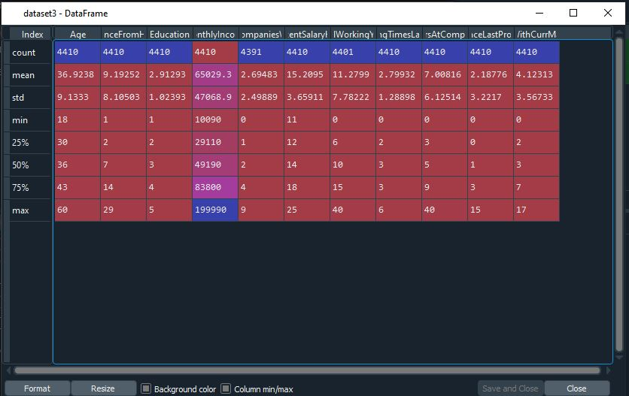

**dataset3=dataset1[['Age','DistanceFromHome','Education','MonthlyIncome',**

**'NumCompaniesWorked', 'PercentSalaryHike','TotalWorkingYears', 'TrainingTimesLastYear',**

**'YearsAtCompany','YearsSinceLastPromotion', 'YearsWithCurrManager']].median()**

**dataset3**

Output:

Age 36.0

DistanceFromHome 7.0

Education 3.0

MonthlyIncome 49190.0

NumCompaniesWorked 2.0

PercentSalaryHike 14.0

TotalWorkingYears 10.0

TrainingTimesLastYear 3.0

YearsAtCompany 5.0

YearsSinceLastPromotion 1.0

YearsWithCurrManager 3.0

dtype: float64

**dataset3=dataset1[['Age','DistanceFromHome','Education','MonthlyIncome',**

**'NumCompaniesWorked', 'PercentSalaryHike','TotalWorkingYears', 'TrainingTimesLastYear',**

**'YearsAtCompany','YearsSinceLastPromotion', 'YearsWithCurrManager']].mode()**

**dataset3**

Output:

Age DistanceFromHome ... YearsSinceLastPromotion YearsWithCurrManager

0 35 2 ... 0 2

[1 rows x 11 columns]

**dataset3=dataset1[['Age','DistanceFromHome','Education','MonthlyIncome',**

**'NumCompaniesWorked', 'PercentSalaryHike','TotalWorkingYears', 'TrainingTimesLastYear',**

**'YearsAtCompany','YearsSinceLastPromotion', 'YearsWithCurrManager']].mean()**

**dataset3**

Output:

Age 36.923810

DistanceFromHome 9.192517

Education 2.912925

MonthlyIncome 65029.312925

NumCompaniesWorked 2.694830

PercentSalaryHike 15.209524

TotalWorkingYears 11.279936

TrainingTimesLastYear 2.799320

YearsAtCompany 7.008163

YearsSinceLastPromotion 2.187755

YearsWithCurrManager 4.123129

dtype: float64

**dataset3=dataset1[['Age','DistanceFromHome','Education','MonthlyIncome',**

**'NumCompaniesWorked', 'PercentSalaryHike','TotalWorkingYears', 'TrainingTimesLastYear',**

**'YearsAtCompany','YearsSinceLastPromotion', 'YearsWithCurrManager']].var()**

**dataset3**

Output:

Age 8.341719e+01

DistanceFromHome 6.569144e+01

Education 1.048438e+00

MonthlyIncome 2.215480e+09

NumCompaniesWorked 6.244436e+00

PercentSalaryHike 1.338907e+01

TotalWorkingYears 6.056298e+01

TrainingTimesLastYear 1.661465e+00

YearsAtCompany 3.751728e+01

YearsSinceLastPromotion 1.037935e+01

YearsWithCurrManager 1.272582e+01

dtype: float64

**dataset3=dataset1[['Age','DistanceFromHome','Education','MonthlyIncome',**

**'NumCompaniesWorked', 'PercentSalaryHike','TotalWorkingYears', 'TrainingTimesLastYear',**

**'YearsAtCompany','YearsSinceLastPromotion', 'YearsWithCurrManager']].skew()**

**dataset3**

Output:

Age 0.413005

DistanceFromHome 0.957466

Education -0.289484

MonthlyIncome 1.368884

NumCompaniesWorked 1.026767

PercentSalaryHike 0.820569

TotalWorkingYears 1.116832

TrainingTimesLastYear 0.552748

YearsAtCompany 1.763328

YearsSinceLastPromotion 1.982939

YearsWithCurrManager 0.832884

dtype: float64

**dataset3=dataset1[['Age','DistanceFromHome','Education','MonthlyIncome',**

**'NumCompaniesWorked', 'PercentSalaryHike','TotalWorkingYears', 'TrainingTimesLastYear',**

**'YearsAtCompany','YearsSinceLastPromotion', 'YearsWithCurrManager']].kurt()**

**dataset3**

Output:

Age -0.405951

DistanceFromHome -0.227045

Education -0.560569

MonthlyIncome 1.000232

NumCompaniesWorked 0.007287

PercentSalaryHike -0.302638

TotalWorkingYears 0.912936

TrainingTimesLastYear 0.491149

YearsAtCompany 3.923864

YearsSinceLastPromotion 3.601761

YearsWithCurrManager 0.167949

dtype: float64

**dataset3=dataset1[['Age','DistanceFromHome','Education','MonthlyIncome',**

**'NumCompaniesWorked', 'PercentSalaryHike','TotalWorkingYears', 'TrainingTimesLastYear',**

**'YearsAtCompany','YearsSinceLastPromotion', 'YearsWithCurrManager']].info()**

<class 'pandas.core.frame.DataFrame'>

RangeIndex: 4410 entries, 0 to 4409

Data columns (total 11 columns):

# Column Non-Null Count Dtype

--- ------ -------------- -----

0 Age 4410 non-null int64

1 DistanceFromHome 4410 non-null int64

2 Education 4410 non-null int64

3 MonthlyIncome 4410 non-null int64

4 NumCompaniesWorked 4391 non-null float64

5 PercentSalaryHike 4410 non-null int64

6 TotalWorkingYears 4401 non-null float64

7 TrainingTimesLastYear 4410 non-null int64

8 YearsAtCompany 4410 non-null int64

9 YearsSinceLastPromotion 4410 non-null int64

10 YearsWithCurrManager 4410 non-null int64

dtypes: float64(2), int64(9)

memory usage: 379.1 KB

**box_plot=dataset1.Age**

**plt.boxplot(box_plot)**

Output:

{'whiskers': [<matplotlib.lines.Line2D at 0x20ae69f6708>,

<matplotlib.lines.Line2D at 0x20ae85fba88>],

'caps': [<matplotlib.lines.Line2D at 0x20ae5df2048>,

<matplotlib.lines.Line2D at 0x20ae69f9c88>],

'boxes': [<matplotlib.lines.Line2D at 0x20ae85ff308>],

'medians': [<matplotlib.lines.Line2D at 0x20ae68ff1c8>],

'fliers': [<matplotlib.lines.Line2D at 0x20ae85f57c8>],

'means': []}

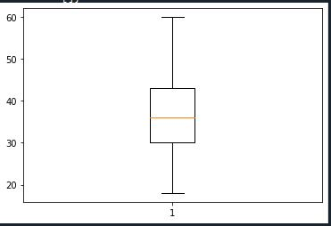

**box_plot=dataset1.MonthlyIncome**

**plt.boxplot(box_plot)**

Output:

{'whiskers': [<matplotlib.lines.Line2D at 0x20ae8e6c588>,

<matplotlib.lines.Line2D at 0x20ae8f1ba08>],

'caps': [<matplotlib.lines.Line2D at 0x20ae8f1bb08>,

<matplotlib.lines.Line2D at 0x20ae8f20988>],

'boxes': [<matplotlib.lines.Line2D at 0x20ae8f19908>],

'medians': [<matplotlib.lines.Line2D at 0x20ae8f20a88>],

'fliers': [<matplotlib.lines.Line2D at 0x20ae8f26908>],

'means': []}

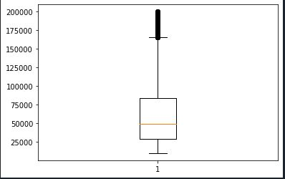

**box_plot=dataset1.YearsAtCompany**

**plt.boxplot(box_plot)**

Output:

{'whiskers': [<matplotlib.lines.Line2D at 0x20ae8f5b788>,

<matplotlib.lines.Line2D at 0x20ae8f8cd88>],

'caps': [<matplotlib.lines.Line2D at 0x20ae8f8ce88>,

<matplotlib.lines.Line2D at 0x20ae8f91dc8>],

'boxes': [<matplotlib.lines.Line2D at 0x20ae8f87c88>],

'medians': [<matplotlib.lines.Line2D at 0x20ae8f91d48>],

'fliers': [<matplotlib.lines.Line2D at 0x20ae8f91f88>],

'means': []}

